Resume Enhancing, Analyzing and Developing using Machine Learning (R.E.A.D.M.L.)
Mushan R. A. ^{*1}, Sankanna A. S.^{*2}, Chidgumpi A. S.^{*3}, Surwase V. V.^{*4}, Prof Pasnur P. S.^{*5}
^{*1,2,3,4,5} Dept. Of Artificial Intelligence & Data Science, V. V. P. Institute of Engineering and Technology, Solapur, Maharashtra, India.

ABSTRACT
R.E.A.D.M.L. is an advanced AI-driven platform designed to enhance the process of resume development and optimization. Built using Python, Streamlit, Natural Language Processing (NLP), and the Gemini API, the system empowers users to either create a new resume from scratch or analyse an existing one. Unlike conventional resume-building tools that focus primarily on layout, R.E.A.D.M.L. offers a comprehensive solution by enabling real-time resume generation, ATS (Applicant Tracking System) scoring, and personalized feedback tailored to each user's profile. With its robust architecture, intelligent document processing, and interactive data visualizations, R.E.A.D.M.L. helps users gain clear insights into their resume's effectiveness, making it highly relevant in today’s digital recruitment landscape.
Keywords: Resume Analysis, Python, Streamlit, Machine Learning, Natural Language Processing, ATS Score, Gemini API, AI feedback, Resume developing, Data Visualization.
- INTRODUCTION
In the era of rising demand for AI and Machine Learning in recruitment, there is a growing need to automate tasks that reduce both time and effort. Traditional resume-building websites primarily focus on layout and design, which often creates problems for candidates when their resumes are evaluated by Applicant Tracking Systems (ATS). R.E.A.D.M.L. addresses this challenge by integrating intelligent algorithms that not only assist in developing a resume but also in analysing it for ATS compatibility. Leveraging modern AI and Natural Language Processing (NLP) techniques, R.E.A.D.M.L. provides real-time feedback to help users identify gaps and improve their resumes effectively. The development of R.E.A.D.M.L. – Resume Enhancing, Analysing & Development using Machine Learning marks a significant advancement in the way resumes are created and evaluated, combining the power of AI and NLP to deliver smarter, more impactful results. A significant step forward in creating and analyzing resumes by integrating the advanced AI & NLP techniques which plays key role in the R.E.A.D.M.L.
- METHODOLOGY
The Development and execution of R.E.A.D.M.L. followed a systematic and structured multiphase methodology which integrates principles from the software engineering, machine learning and also the user experience design
Technical Stack:
- Frontend: Streamlit for UI development
- Backend: Python, custom NLP modules, Gemini API integration
- Document/PDF Processing: wkhtmltopdf, python-docx, PyPDF2
- Visualization: Plotly for good and interactive charts
- MODELING AND ANALYSIS
The R.E.A.D.M.L. provides architecture separates the data gathered, parsed and AI analysis on the parsed data and generates the resume document this process ensures the maintainability and scalability. In the resume parser it utilizes the NLP to identify the sections and extract relevant data for the section. The sections are parsed to the Gemini API which is used as an intelligent resume reviewer which proves the accurate analysis and suggestion of the resume parsed.

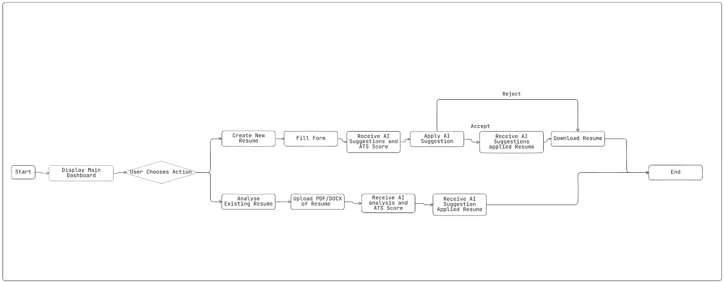
Figure 1: workflow/activity diagram
The Visualization is used to convert the ATS score and other analysis section to the radar, pie chart making user for better experience.
- RESULTS AND DISCUSSION
Testing the R.E.A.D.M.L. which effective advises the key changes, missing skills and format issues that need to be solved/fixed. The ATS system correctly matches the industry benchmarks, the design allows user for easy-to-use advantage without any prior knowledge. The future implementations are such as resume building using the chatbot, from linkedin link to users resume building and many other implementations. It also auto analyzes the resume after the creating the resume from our R.E.A.D.M.L. websites which allows user to know in which section the gap is to fill it the analysis is required.

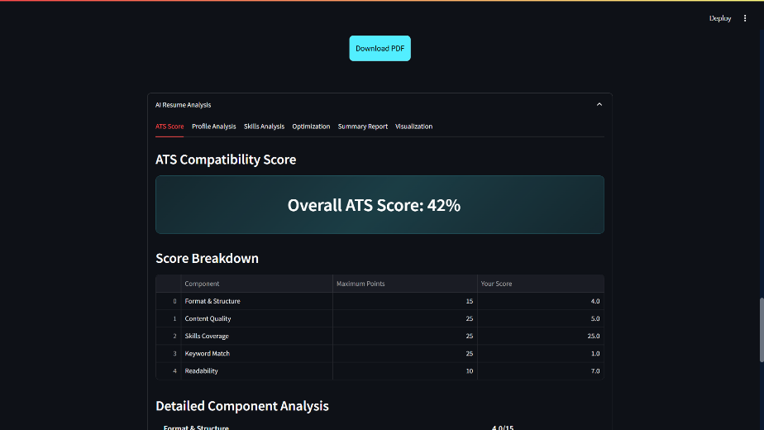
Figure 2: Output of Analysis
- CONCLUSION
This paper successfully demonstrates the implementation of R.E.A.D.M.L. using Python, Stremlit, spacy, NLP and ML. The R.E.A.D.M.L. introduces advancement in the resume building and analysis via AI and give the AI driven analysis with the user-friendly UI. The R.E.A.D.M.L. does not only seamlessly creates good ATS friendly professional resume, it also provides the resume insights for understanding the gap which is required to fill for better chances of passing the ATS score criteria. The future implementations will take the R.E.A.D.M.L. forward with AI capabilities and increasing the accuracy of the AI driven analysis.
ACKNOWLEDGEMENTS
We would like to express our gratitude to Department of Artificial Intelligence and Data Science, VVPIET and our mentor Prof. Pasnur P. S. for their continuous support and guidance throughout the entire project.

- REFERENCES
- S. S. Sonawane, and S. S. Patil, "Resume Analysis and Interpretation Using Artificial Intelligence Technology," International Research Journal of Modernization in Engineering Technology and Science (IRJMETS),vol.6,no.3,pp.1–9,Mar.2024. Available: https://www.irjmets.com/uploadedfiles/paper/issue_3_march_2024/51611/final/fin_irjmets1711890689.pdf
- A. Sharma, P. S. Choudhary, and R. Singh, "Resume Evaluation Research Paper," arXiv preprint, arXiv:2307.15752, 2023. Available: https://arxiv.org/pdf/2307.15752.
- R. K. Gupta and A. K. Sharma, "A Review of Resume Analysis and Job Description Matching Using Machine Learning and NLP," International Journal on Recent and Innovation Trends in Computing and Communication, vol.12,no.2,pp.247–250, 2024. Available: https://ijritcc.org/index.php/ijritcc/article/view/10561.
- HitS. Singh and R. Verma, "Resume Analyzer Using NLP," International Journal of Current Science (IJCSPUB), vol.14,no.1,pp.304–310,Mar.2024. Available: https://rjpn.org/ijcspub/papers/IJCSP24A1150.pdf

